DSA Project using PYTHON

* **Introduction:**
* This project is made to easily understand the DSA concepts like STACK, QUEUE, CIRCULAR QUEUE using visualization.
* For backend : Python
* For Frontend: HTML, CSS, JavaScript
* **Problem Domain:**
* As this 3 concepts (Stack, Queue & Circular Queue) are very similar and create some confusion to understand.
* The main confusion is created because 3 of them have different rules and methods.
* **Solution Domain:**
* To solve this problems I visualized this 3 concepts that makes it easy for user to understand.
* **Requirements:**
* Software: Visual Studio , for browser Crome.
* Hardware:
  + Processor: Any modern processor.
  + RAM: At least 2GB.
  + Storage: 100MB for project files.
  + Display: Resolution of 1366x768.
* **Data Structure Used:**
* I used STACK which follow LIFO principle
* I used QUEUE which follow FIFO principle
* I used CIRCULAR QUEUE which follow FIFO principle
* **Methodology:**

STEP 1:- Firstly open this Page

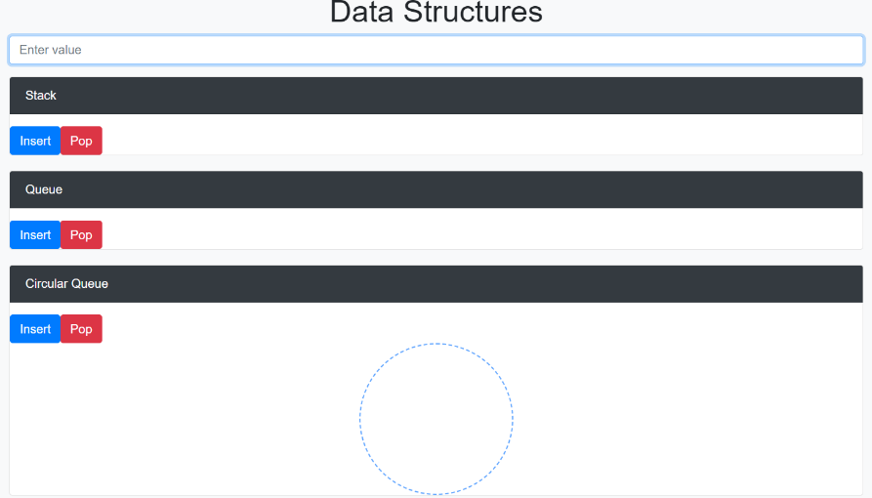

STEP 2:- Insert 40, 50, 60 values in stack

STEP 3:- POP 60 from Stack

STEP 4:- Inserting 10,20,30,40 values in Queue

Step 5:- POP 10 & 20 from Queue

Step 6:- Insert 15, 30,45,60,75,90 values in Circular Queue

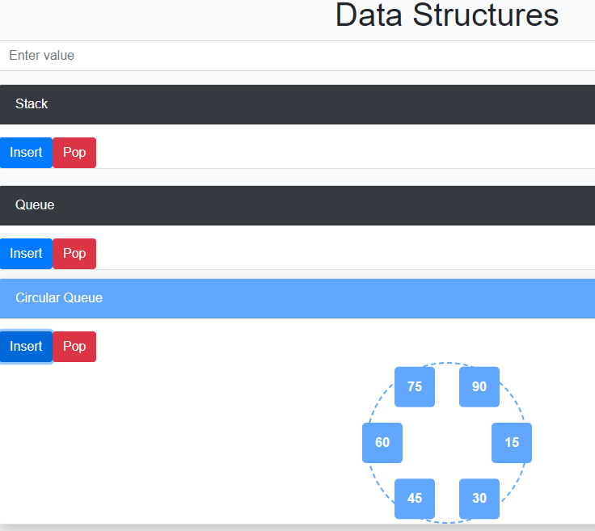

Step 7:- POP 15 & 30 from Circular Queue

* **Summary:**
  + This 3 concepts (Stack, Queue & Circular Queue) are very similar and create some confusion to understand.
  + User are confused to which Principal (LIFO or FIFO) is used in particular Structure.
  + So, in my project using Visualization user can easily understand.
  + In this website firstly Enter value than click INSERT button in which you want to add.
  + Enter some values than use POP button which is given particular in structures.
* **Conclusion:**
* Using this project user can easily understand the DSA concepts.